 | Year 12 Methods  Term 2 Week 1 Quiz | $$\frac{}{20}$$

Name: __________________
1. | Suppose that X is the number of times a shooter hits a target in a competition. If the distribution of X is binomial, with probability of success of 0.67, calculate the probability that a shooter who takes five shots will hit the target three times. | 2
2. | A multiple choice test has 10 questions, each of whci has five possible answers. Find the probabillity that a student who guesses the answer to each question will have:  - No correct answers  - 5 or more correct answers  - At least 7 correct answers given that they have at least 5 correct answers. | 4
3. | 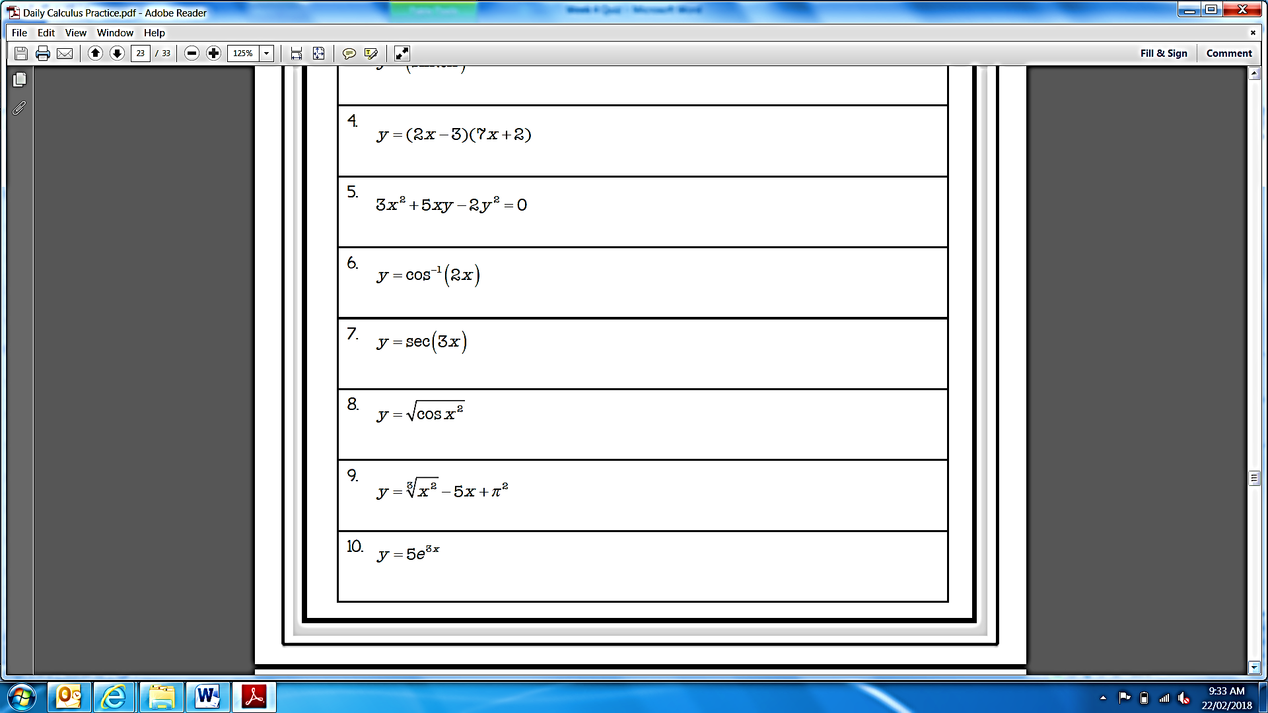  Find:  - The derivative of  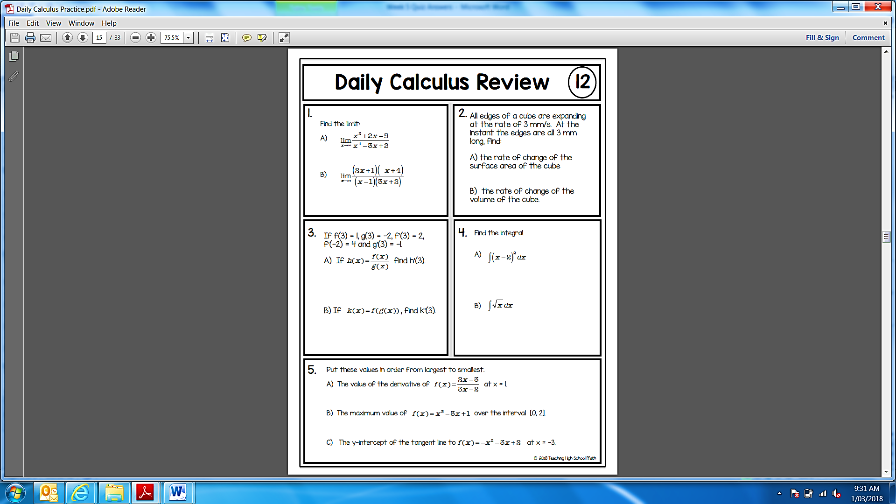 | 3
4. | The velocity of a body as a function of time is given as $v\left(t\right)=5e^{-2t}+4$, where t is on seconds and v is in m/s. What is the acceleration at t = 0.6? | 3
5. |  | 8

